**Web programming**

**Lab 1**

**Task 1:**

<!DOCTYPE html>

<html lang="en">

<head>

    <meta charset="UTF-8">

    <meta name="viewport" content="width=device-width, initial-scale=1.0">

    <title>Document</title>

</head>

<body>

    <h1>Name:</h1>

    <p>Ahmad Ali</p>

    <h1>Roll No :</h1>

    <p>21F-9268</p>

    <h1>Description:</h1>

    <P>HI!. I am ahmad ali from lahore. i am doing my bachlor in computer science from fast national university cfd campus</P>

</body>

</html>

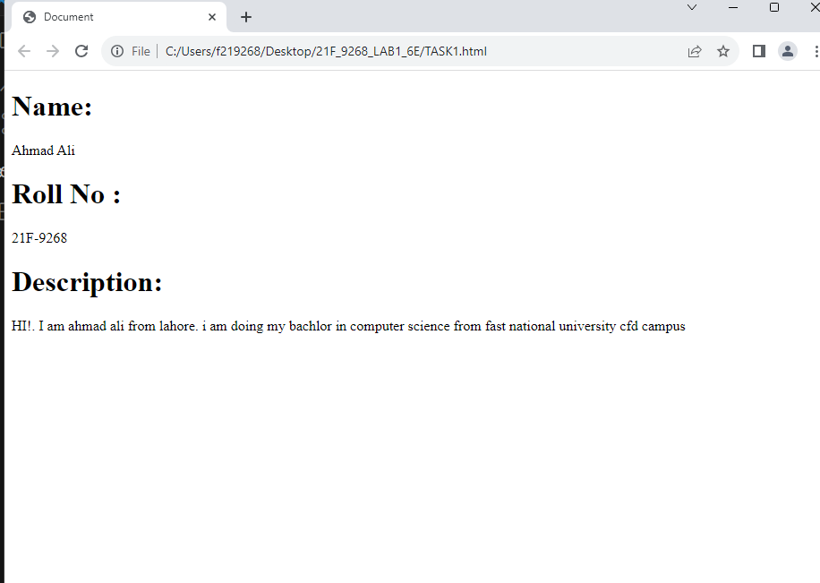

**Task 2:**

<!DOCTYPE html>

<html lang="en">

<head>

    <meta charset="UTF-8">

    <meta name="viewport" content="width=device-width, initial-scale=1.0">

    <title>Document</title>

</head>

<body>

    <b> This text is bold</b>

    <br>

    <big>this text is big</big>

    <br>

    <strong> this text is strong</strong>

    <br>

    <i> this is italic</i>

    <br>

    <em>this text is emphasize</em>

    <br>

    <p>this text is computer text </p>

    <br>

    <sup>this text is supscript</sup>

    <br>

    <sub>this text is subscript</sub>

</body>

</html>

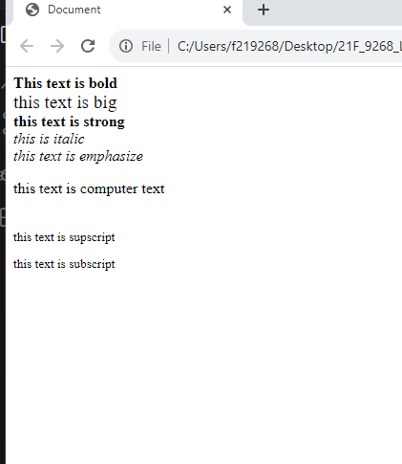

**Task 3:**

<!DOCTYPE html>

<html lang="en">

<head>

    <meta charset="UTF-8">

    <meta name="viewport" content="width=device-width, initial-scale=1.0">

    <title>Document</title>

</head>

<body>

    <img src="fast logo.png" alt="The university logo" width="500" height="500">

</body>

</html>



**Task 4:**

<!DOCTYPE html>

<html lang="en">

<head>

    <meta charset="UTF-8">

    <meta name="viewport" content="width=device-width, initial-scale=1.0">

    <title>Document</title>

</head>

<body>

   <a href="https://www.nu.edu.pk/" target="_blank"> <img src="fast logo.png" alt="The university logo" width="500" height="500"></a>

</body>

</html>



**Task 5:**

<!DOCTYPE html>

<html lang="en">

<head>

    <meta charset="UTF-8">

    <meta name="viewport" content="width=device-width, initial-scale=1.0">

    <title>Document</title>

</head>

<body>

    <p>

        <h1>HTML LISTS</h1>

        <H2>Unordered List</H2>

        we have books on variety of languages:

        <ul>

            <li>Oracle</li>

            <li>JAVA</li>

            <li>HTML</li>

            <li>CSS</li>

        </ul>

        <H2>Order list</H2>

        follow these step to install java:

        <ol>

            <li>download the software</li>

            <li>Extract to a folder</li>

            <li>double click the executable to run</li>

        </ol>

    </p>

</body>

</html>

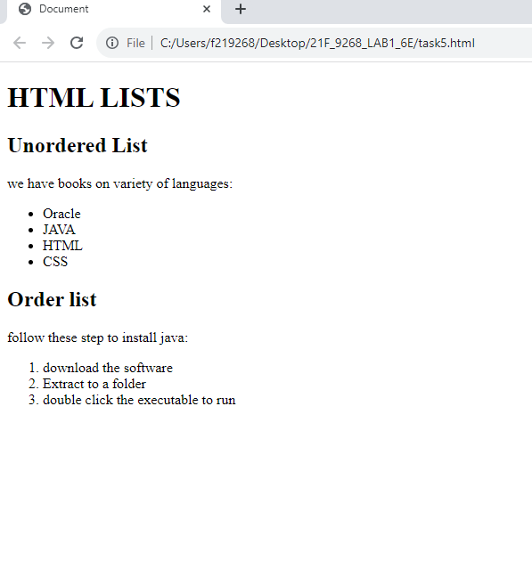

**Task 6:**

<!DOCTYPE html>

<html lang="en">

<head>

    <meta charset="UTF-8">

    <meta name="viewport" content="width=device-width, initial-scale=1.0">

    <title>Document</title>

</head>

<body>

    <table border="1" width="300" height ="100">

        <tr>

            <th rowspan="3">APRIL</th>

            <th>   </th>

            <th>   </th>

          </tr>

          <tr>

            <th>   </th>

            <th>   </th>

          </tr>

          <tr>

            <th>   </th>

            <th>   </th>

          </tr>

          <tr>

            <th>   </th>

            <th>   </th>

            <th>   </th>

          </tr>

          <tr>

            <th>   </th>

            <th>   </th>

            <th>   </th>

          </tr>

      </table>

</body>

</html>

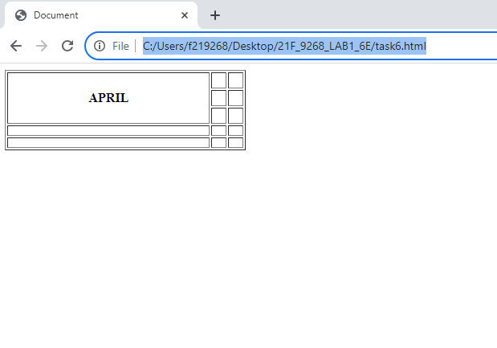

**Task 7:**

**Task 8:**